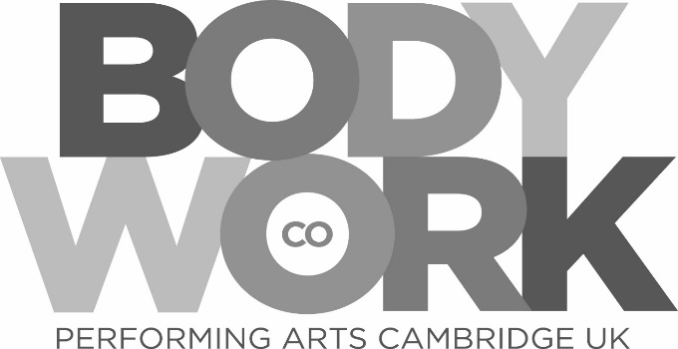

**Video Audition Demonstration Criteria 2020**

**All applicants applying via Video demonstration must include the following demonstrations**

* All applicants will need to prepare a Dance solo in a preferred discipline, any style or genre. This must be 2-3 minutes long. (E.g. street dance, Jazz, Tap etc)
* Song solo 2-3 minutes long. This can be from a Musical or popular music.
* You must choose and prepare a 2-3 minute monologue from a recent play (over the past 20 years). The characters background should be researched and should be of similar age to you.
* Please email these to [sonya.segrave@bodyworkds.co.uk](mailto:sonya.segrave@bodyworkds.co.uk)
* If the files are too big please feel free to use Drop Box or WeTransfer

