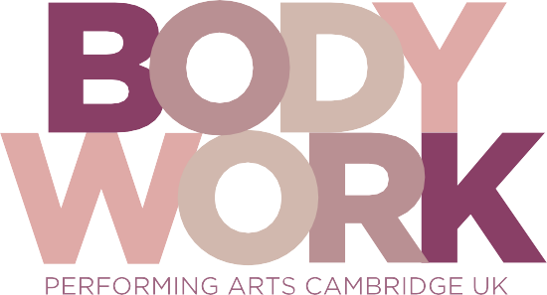
Bodywork Company Dance Studios
@BodyworkDance
Bodyworkcompanydancestudios

INST

TERM DATES ACADEMIC YEAR 2019-20

Autumn Term 2019
Monday 23rd September Foundation students
Tuesday 24th September 1st years plus any NEW 2nd & 3rd years
Thursday 26th September 2nd and 3rd years return
Thursday 17th October OPEN DAY for NEW prospective students
21st – 25th October Half-Term
Thursday 7th November OPEN DAY for NEW prospective students
Thursday 12th December OPEN DAY – families of current students
Thursday 12th December Carol Concert
Friday 13th December Performing Arts Christmas Show
End of Term
Spring Term 2020
Monday 6th January Start of spring term
17th – 21st February Half-Term
Friday 27th March End of term

Summer Term 2020
Monday 20th April Start of summer term
Monday 4th May Bank Holiday
25th – 29th May Half Term
Friday 10th July End of term

Please note that the end of year show will be on Friday July 10th & Saturday July 11th 2020.
The 3rd year Graduation Ball will be on Sunday 12th July 2020.

Bodywork Company Dance Studios, 25-29 Glisson Road, Cambridge CBI 2HA
Telephone: 01223 314461 • Email: admin@bodyworkds.co.uk • Web: www.bodyworkcompany.co.uk

